December 11, 2023
Contact: Amanda Gamby 419-354-6222

Public Input Needed – Online Interactive Map for Traffic Improvements in Northwest Ohio
BOWLING GREEN— The City of Bowling Green, along with the Wood, Lucas, Ottawa, and Sandusky County Engineer’s offices, is seeking the help of every citizen in northwest Ohio to improve the safety of our transportation network across the region. Community members are encouraged to submit traffic improvement suggestions by accessing the Northwest Ohio Transportation Safety Plan public input map linked on the City’s homepage: www.bgohio.org or the Wood County Engineer’s website: https://engineer.co.wood.oh.us
This online tool allows users to point to any location on the map within Wood, Lucas, Ottawa, and Sandusky counties and provide constructive feedback on the safety and efficiency of these places. Users can comment on anything from observations of bad driving behaviors, like speeding and distracted driving, or on improvements needed, ranging from significant projects like a roundabout or road widening, to more simple fixes like restriping the road or new lighting. Both positive feedback, identifying where things are working, and critical feedback, identifying areas for improvement and change, are welcome and encouraged.
The map will be live and open for comment until January 15, 2024.
In February, the Wood County Engineer’s Office, along with Lucas, Ottawa and Sandusky counties, was one of 510 recipients nationwide to receive a $400,000 federal grant as part of the new Safe Streets and Roads for All Program (SS4A). This grant allows for the creation of a Transportation Safety Action Plan, which will identify measures, locations and projects that will lead to a safer and more equitable transportation system, with the main goal of reducing traffic fatalities.
This year, all four County Engineer’s offices have been working with transportation consulting firm Toole Design to develop this action plan, looking at traffic crash data and identifying the biggest problem areas across the region, and diving into the why’s and how’s, including driver behaviors and user access to safe roads and transportation methods. The core advisory team has been speaking with stakeholders and representatives across all four counties, urban, suburban and rural as well as different users of the systems from car and motorcycle drivers to users of public transportation, bicycles and other modes.
“Improving transportation safety is an effort everyone can participate in,” Wood County Engineer John Musteric said. “To that end, we are asking all types of road users to take a few minutes to help shape the plan to be as impactful as possible as we endeavor to reach the goal of zero deaths on our roadways,” he said.

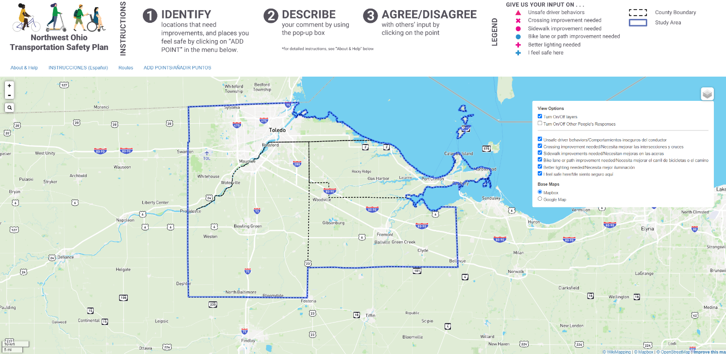
Figure 1 Pictured is the public input map, landlocked by Lucas, Wood, Ottawa, and Sandusky counties, where users can comment on the traffic safety of any point across the region.

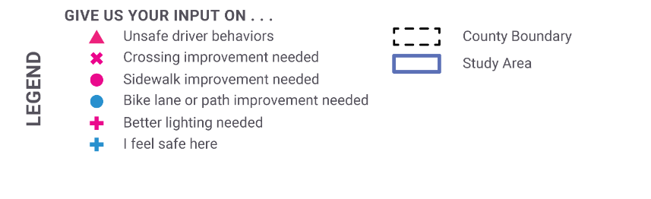
Figure 2 The map legend offers suggestions on the types of feedback users can provide input on, but any suggestion or comment relating to/concerning traffic safety may be added.

# # #

23-214

